Docker
Docker is a platform designed to help developers build, share, and run applications in containers.
Containers package everything an application needs:
- Code
- Dependencies
- Libraries
- Runtime
This ensures the application runs the same everywhere.

Why Do We Need Docker?

1. Consistency Across Applications

Problem
You build an application on your system, and it works perfectly.
But when your teammate runs the same code, it fails due to:
- Different Python versions
- Missing libraries
- OS differences
Classic issue:
“It works on my machine, but not on yours.”

Solution (Docker)
Docker solves this by packaging:
- Application code
- Exact dependencies
- Environment configuration
into a container.
Now the application will run exactly the same on:
- Your laptop
- Teammate’s system
- Production server

2. Isolation

Problem
You are working on multiple projects:
- Project A → requires Python 3.8
- Project B → requires Python 3.11
Installing both on the same system causes:
- Version conflicts
- Dependency clashes
- Environment mess

Solution (Docker)
Docker runs each application in its own isolated container.
Each container has:
- Its own Python version
- Its own libraries
- Its own environment
So:
- Project A runs independently
- Project B runs independently
No conflicts at all.

3. Scalability

Problem
Your application suddenly gets high traffic (e.g., website or API).
Without Docker:
- You manually set up multiple servers
- Install dependencies again and again
- Hard to manage and slow to scale

Solution (Docker)
Docker allows you to:
- Create multiple container instances quickly
- Run them in parallel
- Scale up/down easily
For example:
- 1 container → normal traffic
- 10 containers → high traffic
Tools like Kubernetes can automatically:
- Scale containers
- Balance load
Docker helps in:
- Consistency → Same environment everywhere
- Isolation → No conflicts between projects
- Scalability → Easily handle growth

Docker Engine
Docker Engine is the core component of the Docker platform responsible for:
- Creating containers
- Running containers
- Managing containers
It acts as the runtime that powers Docker’s containerization capabilities.
In simple terms:
Docker Engine is the brain behind Docker that actually makes containers work.

Components of Docker Engine
Docker Engine mainly consists of three key components:

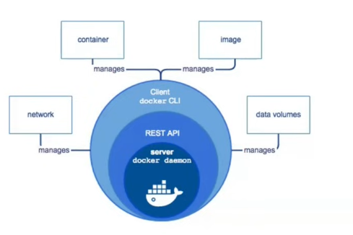

1. Docker Daemon (dockerd)

What it does
- Runs in the background
- Manages Docker objects like:
  - Containers
  - Images
  - Networks
  - Volumes

Role
It is the main engine that does all the actual work.
Example:
When you run a container, the daemon is the one that:
- Pulls the image
- Creates the container
- Starts it

2. Docker CLI (Command Line Interface)

What it does
- Allows users to interact with Docker
- You use commands like:
docker run
docker build
docker pull

Role
It acts as the interface between user and Docker
Example:
When you type:
docker run nginx
You are using the CLI.

3. Docker REST API

What it does
- Allows communication between:
  - Docker CLI
  - Docker Daemon

Role
Acts as a bridge (communication layer)
Flow:
User → Docker CLI → REST API → Docker Daemon → Container runs

Complete Flow
- You give a command using Docker CLI
- CLI sends request via REST API
- Docker Daemon receives it
- Daemon performs the action (run container, pull image, etc.)
- Docker CLI → You interact here
- REST API → Communication layer
- Docker Daemon → Does the actual work
Together, they form the Docker Engine

Docker Images
A Docker Image is a lightweight, standalone package that contains everything needed to run an application.
It includes:
- Application code
- Dependencies
- Runtime
- Configuration
In simple terms:
A Docker image is like a blueprint used to create containers.

Components of a Docker Image

1. Base Image

What it is
The starting point of any Docker image.

Example
- Ubuntu
- Alpine
- Python

Role
Provides:
- Operating system environment
- Basic tools and libraries
Every image is built on top of a base image

2. Application Code

What it is
The actual code of your application.

Example
- Python scripts
- Node.js app
- Java application

Role
Defines what your application does

3. Dependencies

What it is
All the libraries and packages required to run the application.

Example
- Python libraries (numpy, flask)
- Node modules

Role
Ensures the app runs without missing requirements

4. Metadata

What it is
Information about the image.

Includes
- Environment variables
- Default command (CMD)
- Exposed ports

Role
Helps Docker understand how to run the container

Docker Image Lifecycle

1. Creation

Process
- A Docker image is created using a Dockerfile

What happens
- Base image is selected
- Code is added
- Dependencies are installed
Command:
docker build -t myapp .

2. Storage

Process
- Images are stored in a registry

Example
- Docker Hub
- Private registries
Think of it as a repository for images

3. Distribution

Process
- Images are shared or pulled from a registry
Commands:
docker push myapp
docker pull myapp
Allows teams to share applications easily

4. Execution

Process
- Image is used to create and run a container
Command:
docker run myapp

What happens
- Container is created from image
- Application starts running

Lifecycle Summary
Create → Store → Distribute → Run

Dockerfile
A Dockerfile is a text file that contains a set of instructions used to build a Docker image.
In simple terms:
It is a recipe that tells Docker:
- What base to use
- What to install
- What code to copy
- How to run the application

Why Do We Need Dockerfile?
Without a Dockerfile:
- You would manually install dependencies
- Copy code every time
- Configure environment again and again
With Dockerfile:
- Everything becomes automated & repeatable

Basic Structure of a Dockerfile
Here is a simple example:
# Step 1: Base Image
FROM python:3.10
# Step 2: Set working directory
WORKDIR /app
# Step 3: Copy files
COPY . .
# Step 4: Install dependencies
RUN pip install -r requirements.txt
# Step 5: Command to run
CMD ["python", "app.py"]

Important Instructions in Dockerfile

1. FROM

Purpose
Defines the base image

Example
FROM python:3.10
Every Dockerfile must start with FROM

2. WORKDIR

Purpose
Sets the working directory inside the container
WORKDIR /app
Like doing cd /app

3. COPY

Purpose
Copies files from your system to container
COPY . .
First . = local folder
Second . = container folder

4. RUN

Purpose
Executes commands during build time
RUN pip install -r requirements.txt
Used to install dependencies

5. CMD

Purpose
Defines the default command to run the container
CMD ["python", "app.py"]
Runs when container starts

How Dockerfile Works
- Docker reads Dockerfile
- Executes instructions one by one
- Creates layers for each step
- Combines layers into an image

Real-Life Analogy
Dockerfile = Recipe
Image = Prepared dish
Container = Served food

Build & Run Commands

Build Image
docker build -t myapp .

Run Container
docker run myapp

Docker Container
A Docker Container is a lightweight, executable unit that contains:
- Application code
- Dependencies
- Runtime environment
Containers are created from Docker Images.
In simple terms:
Image = Blueprint
Container = Running application
Containers allow applications to run consistently across different environments because everything required is packaged inside them.

Characteristics of Docker Containers
- Lightweight (shares OS kernel)
- Fast startup
- Portable
- Isolated from other containers

How Containers Work
- Docker uses an image
- Creates a container from it
- Runs the application inside
Command:
docker run myapp

Docker Registry
A Docker Registry is a service that:
- Stores Docker images
- Distributes them
It acts like a repository for Docker images

Types of Docker Registries

1. Public Registry

Example
- Docker Hub

Features
- Open to everyone
- Anyone can pull images
- Used for sharing publicly
Example:
docker pull nginx

2. Private Registry

Features
- Restricted access
- Used within organizations
- Secure image storage
Examples:
- AWS ECR
- Google Container Registry

3. Self-Hosted Registry

Features
- Hosted on your own server
- Full control over images
- Custom security configurations
Example:
- Running your own Docker registry using Docker

Container Lifecycle

1. Create
Container is created from an image:
docker create myapp

2. Start
Container starts running:
docker start myapp

3. Stop
Stops the container:
docker stop myapp

4. Restart
Restarts container:
docker restart myapp

5. Delete
Removes container:
docker rm myapp

Final Understanding
- Docker Image → Static blueprint
- Docker Container → Running instance
- Docker Registry → Storage system for images

Full Flow
Dockerfile → Image → Registry → Container
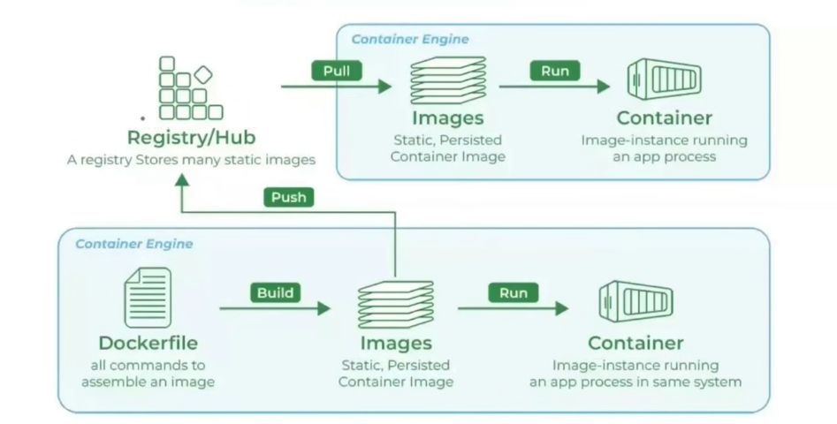

Docker Compose
Docker Compose is a tool used to define and run multi-container Docker applications.
In simple terms:
It allows you to run multiple containers (like backend, database, frontend) together using a single file.

Why Do We Need Docker Compose?

Problem
Imagine you have:
- A backend (Python app)
- A database (MySQL)
Without Docker Compose:
- You run multiple docker run commands
- Manually connect containers
- Manage ports and networks yourself
This becomes complex and error-prone.

Solution
Docker Compose solves this by:
- Defining everything in one YAML file
- Running all services with a single command

Docker Compose File
The configuration is written in a file named:
docker-compose.yml

Basic Structure
version: '3'
services:
app:
build: .
ports:
- "5000:5000"
db:
image: mysql
environment:
MYSQL_ROOT_PASSWORD: root

Key Components

1. version
Defines the version of Docker Compose file format.

2. services
This is the most important section.
Each service represents a container

3. build
build: .
Builds image from Dockerfile in current directory

4. image
image: mysql
Pulls image from Docker Hub

5. ports
ports:
- "5000:5000"
Maps local port to container port

6. environment
environment:
MYSQL_ROOT_PASSWORD: root
Sets environment variables

How to Use Docker Compose

Step 1: Start All Services
docker-compose up
Builds and runs all containers

Step 2: Run in Background
docker-compose up -d

Step 3: Stop Services
docker-compose down

Real-Life Example
Suppose your app needs:
- Backend → Python
- Database → MySQL
Docker Compose will:
- Start both containers
- Connect them automatically
- Manage networking

Final Understanding
- Docker Compose manages multi-container apps
- Uses a single docker-compose.yml file
- Runs everything with one command

Flow
docker-compose.yml → Multiple Containers → Run Together

Step 1: Install Docker Desktop

Docker Desktop
When we install Docker Desktop, it automatically installs the Docker Engine on our system.

What Happens After Installation?
- Docker Engine runs in the background
- It is responsible for:
  - Creating Docker images
  - Running containers
  - Managing containers
In short, Docker Engine handles all the core operations of Docker

Graphical User Interface (GUI)
Along with Docker Engine, Docker Desktop also provides a GUI (Graphical User Interface).

What you can do using GUI:
- View all Docker images
- See running and stopped containers
- Start/stop containers
- Monitor container activity
This makes Docker easier to use without writing commands.

How GUI Works Internally
The GUI does not directly manage containers.

Communication Flow:
Docker Desktop GUI → Docker API → Docker Engine → Containers

Explanation:
- GUI sends requests
- Docker API acts as a communication bridge
- Docker Engine executes the request
- Results are shown back in GUI

Final Understanding
- Docker Engine → Core backend (does actual work)
- Docker Desktop GUI → User interface (visual control)
- Docker API → Communication layer between them
So even when you click buttons in GUI,
internally it is just calling Docker commands via API.

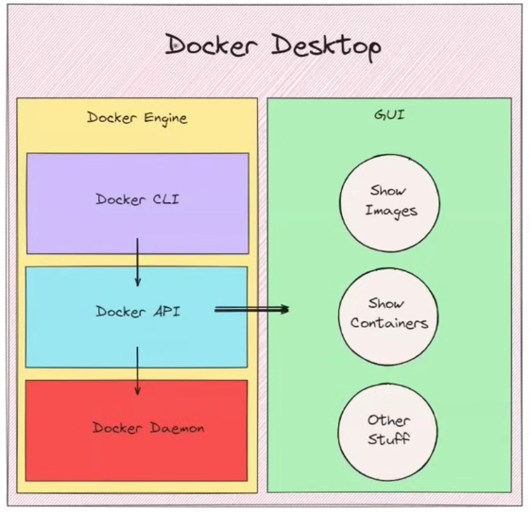

Step 2: Hit (hub.docker.com)
Docker Hub is a cloud-based registry service provided by Docker that allows developers to store, share, and manage Docker images. It acts like a central repository where you can pull ready-made images (like Python, Nginx) or push your own images to share with others. Docker Hub supports both public repositories (accessible to everyone) and private repositories (restricted access), making it useful for both open-source and secure organizational use.
Create a account on hub.docker.com and using same account log in on your docker desktop which helps in authentication when you want to upload your created images on the hub.

Pulling a Sample Image from Docker Hub (Hello World)

Step 1: Install Docker
Make sure Docker Desktop is installed and running on your system.

Step 2: Open Terminal / Command Prompt
- Windows → Command Prompt / PowerShell
- Mac/Linux → Terminal

Step 3: Pull the Image from Docker Hub
Run the following command:
docker pull hello-world
This command downloads the hello-world image from Docker Hub to your local machine.

Step 4: Verify the Image
Check if the image is downloaded:
docker images
You should see hello-world in the list.

Step 5: Run the Container
Run the image using:
docker run hello-world

Step 6: Output
After running, you will see a message like:
Hello from Docker!
This message shows that your installation appears to be working correctly.

What Just Happened?
- Docker pulled the image from Docker Hub
- Created a container
- Ran the container
- Displayed output

Steps to Create a Docker Image and Upload it to Docker Hub
Let’s understand the complete process using a sample image name:
gurleen123/my-python-app

Step 1: Create requirements.txt
Create a file named requirements.txt in your project folder.

Example:
flask
requests
This file contains all the dependencies required for your application.

Step 2: Create a Dockerfile
Create a file named Dockerfile (no extension) in the same folder.

Basic Instructions to Include in Dockerfile:
- Define base image
- Set working directory
- Copy project files
- Install dependencies
- Define command to run app

Example Dockerfile:
FROM python:3.10
WORKDIR /app
COPY . .
RUN pip install -r requirements.txt
CMD ["python", "app.py"]

Step 3: Build the Docker Image
Open a fresh terminal and run:
docker build -t gurleen123/my-python-app .

Explanation:
- -t → tag (name of the image)
- gurleen123/my-python-app → your Docker Hub username + image name
- . → current directory
This command creates your Docker image.

Step 4: Run the Container
Now run the image by creating a container:
docker run -p 5000:5000 gurleen123/my-python-app

Explanation:
- -p 5000:5000 → maps local port to container port
- First 5000 → your system
- Second 5000 → container
Your application will now run inside a container.

Step 5: Login to Docker Hub
Before uploading, login using:
docker login
Enter your Docker Hub username and password.

Step 6: Push Image to Docker Hub
docker push gurleen123/my-python-app
This uploads your image to Docker Hub.

Final Workflow
requirements.txt → Dockerfile → Build Image → Run Container → Push to Docker Hub
- You define dependencies → requirements.txt
- You define environment → Dockerfile
- You build image → docker build
- You run app → docker run
- You share image → docker push

